**REST - Country Web Service**

**pom.xml**

<project xmlns="http://maven.apache.org/POM/4.0.0"

xmlns:xsi="http://www.w3.org/2001/XMLSchema-instance"

xsi:schemaLocation="http://maven.apache.org/POM/4.0.0 https://maven.apache.org/xsd/maven-4.0.0.xsd">

<modelVersion>4.0.0</modelVersion>

<parent>

<groupId>org.springframework.boot</groupId>

<artifactId>spring-boot-starter-parent</artifactId>

<version>3.1.3</version>

<relativePath/>

</parent>

<groupId>com.cognizant</groupId>

<artifactId>spring-learn</artifactId>

<version>0.0.1-SNAPSHOT</version>

<name>spring-learn</name>

<properties>

<java.version>17</java.version>

</properties>

<dependencies>

<!-- Spring Web -->

<dependency>

<groupId>org.springframework.boot</groupId>

<artifactId>spring-boot-starter-web</artifactId>

</dependency>

<!-- Spring Context (to load XML) -->

<dependency>

<groupId>org.springframework</groupId>

<artifactId>spring-context</artifactId>

</dependency>

</dependencies>

<build>

<plugins>

<plugin>

<groupId>org.springframework.boot</groupId>

<artifactId>spring-boot-maven-plugin</artifactId>

</plugin>

</plugins>

</build>

</project>

**Country.java**

package com.cognizant.springlearn.model;

public class Country {

private String code;

private String name;

public Country() {}

public String getCode() {

return code;

}

public void setCode(String code) {

this.code = code;

}

public String getName() {

return name;

}

public void setName(String name) {

this.name = name;

}

}

**Country.xml**

<?xml version="1.0" encoding="UTF-8"?>

<beans xmlns="http://www.springframework.org/schema/beans"

xmlns:xsi="http://www.w3.org/2001/XMLSchema-instance"

xsi:schemaLocation="http://www.springframework.org/schema/beans

https://www.springframework.org/schema/beans/spring-beans.xsd">

<bean id="in" class="com.cognizant.springlearn.model.Country">

<property name="code" value="IN"/>

<property name="name" value="India"/>

</bean>

</beans>

**CountryController Code:**

package com.cognizant.springlearn.controller;

import com.cognizant.springlearn.model.Country;

import org.springframework.context.ApplicationContext;

import org.springframework.context.support.ClassPathXmlApplicationContext;

import org.springframework.web.bind.annotation.RequestMapping;

import org.springframework.web.bind.annotation.RestController;

@RestController

public class CountryController {

@RequestMapping("/country")

public Country getCountryIndia() {

ApplicationContext context = new ClassPathXmlApplicationContext("country.xml");

Country country = (Country) context.getBean("in");

return country;

}

}

**Output**

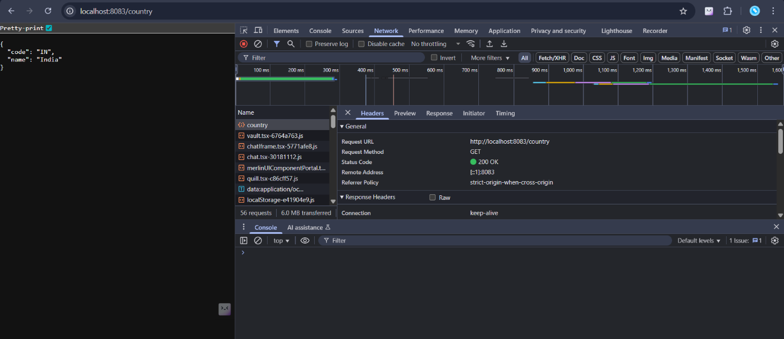

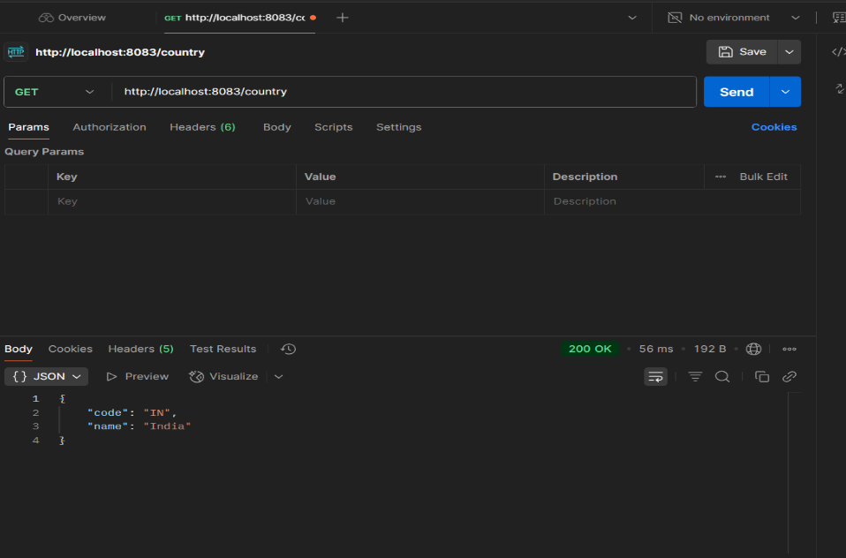**n:**